STONE display +STM32 +Coffee Maker

# Introduction

I am a MCU software engineer, recently received a project is to be a coffee machine, household requirements with a touch screen operation, function is good, is above the screen selection may not be very good, fortunately, this project I can decide what MCU to use myself, also can be used to decide what the screen, so I chose the STM32 of this kind of simple and easy MCU to use, display screen I chose STONE's touch screen display, the screen is simple and easy to use, My STM32 MCU only through UART communication is ok with it.

STONE serial LCD display screen, which can communicate through the serial port of MCU. At the same time, the logic design of the UI interface of this display screen can be designed directly by using the **[STONE TOOL Box](https://www.stoneitech.com/support/download/software)** provided by STONE's official website, which is very convenient. So I'm going to use it for this coffee machine project.

At the same time, I will simply record the basic development. Since this is a project of my company, I will only record a simple demo and not write the complete code. Some basic tutorial about STONE display screen, can go to the website: <https://www.stoneitech.com/>

The website has a variety of information about the model, use and design documentation, as well as video tutorials.I won't go into too much detail here.

## Coffee machine display screen function introduction

This project has the following functions:

* Displays the current time and date
* There are four buttons on the display for americano, latte, cappuccino and espresso.)
* Displays the current amount of remaining coffee beans, milk, and coffee sugar
* A text display box displays the current state

With these concepts in mind, you can design a UI interface. STONE of the touch screens in the UI design is relatively simple, the user through PhotoShop software design good UI interface and button effect, through the **STONE TOOL Box** to design good pictures into the screen, and add your own buttons with STONE TOOL Box logic and serial data the return value is ok, very easy for you to develop.

# Make UI pictures for STONE display

According to functional requirements, I made the following two UI display interfaces, one is the main interface and the other is the button effect.

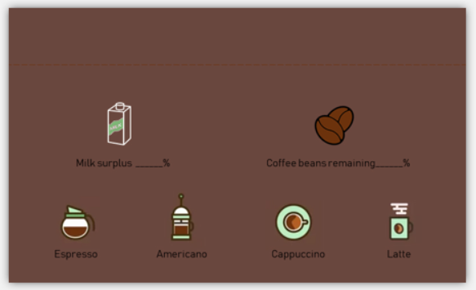

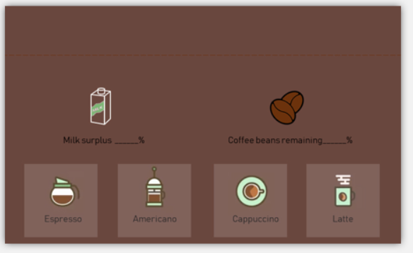

## Use of STONE TOOL Box

Currently, STONE provides TOOL. Open this TOOL to create a new project, then import the designed UI to display pictures, and add your own buttons, text display boxes, etc. The official website of STONE has a very complete tutorial on how to use this software：

<https://www.stoneitech.com/support/download/video>

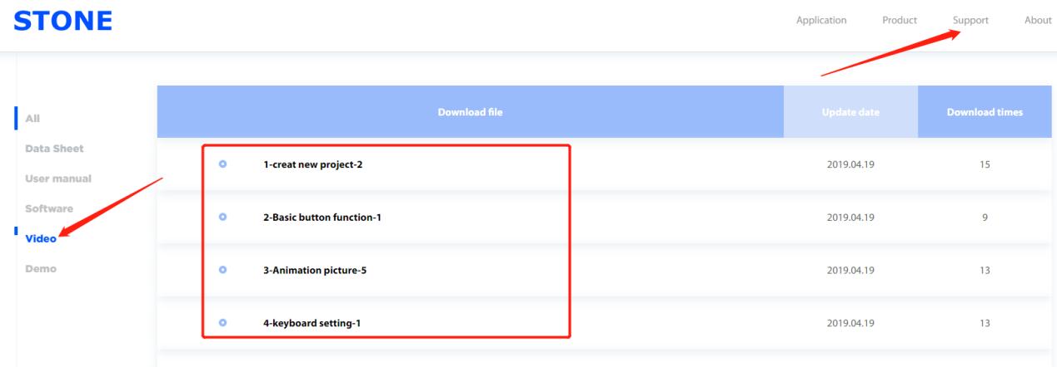

The effects of adding buttons and displaying components in the **STONE TOOL Box** are as follows:

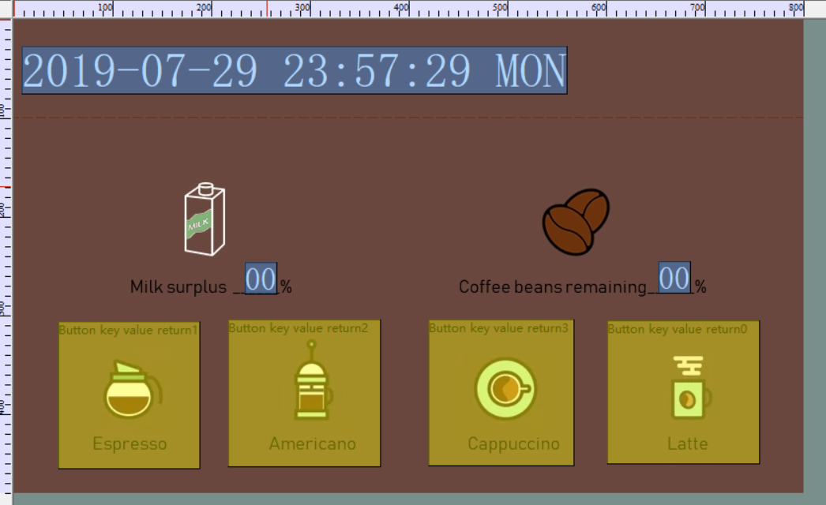

**STONE TOOL Box** has the function of simulation display, through which you can see the operation effect of UI interface:

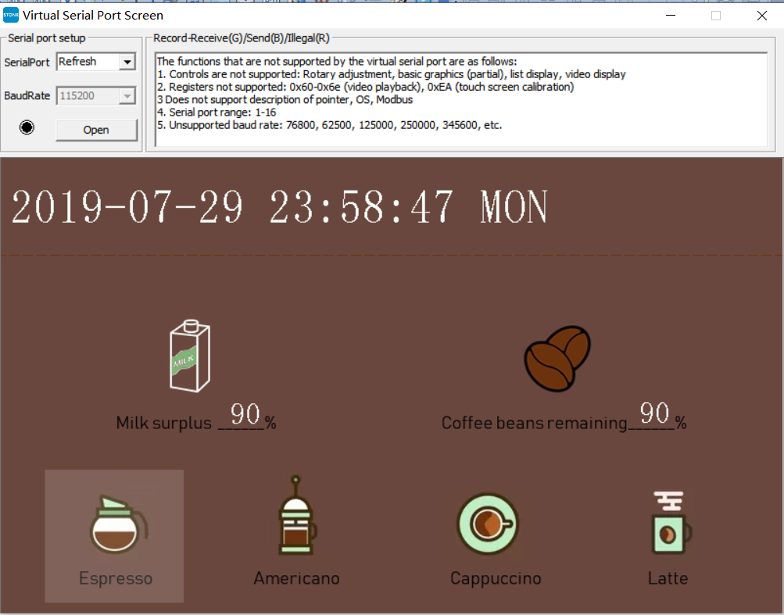

At this point, my UI display is complete, and all I have to do is write the MCU code.

Download the files generated by the **STONE TOOL Box** onto the display screen to see the actual results.

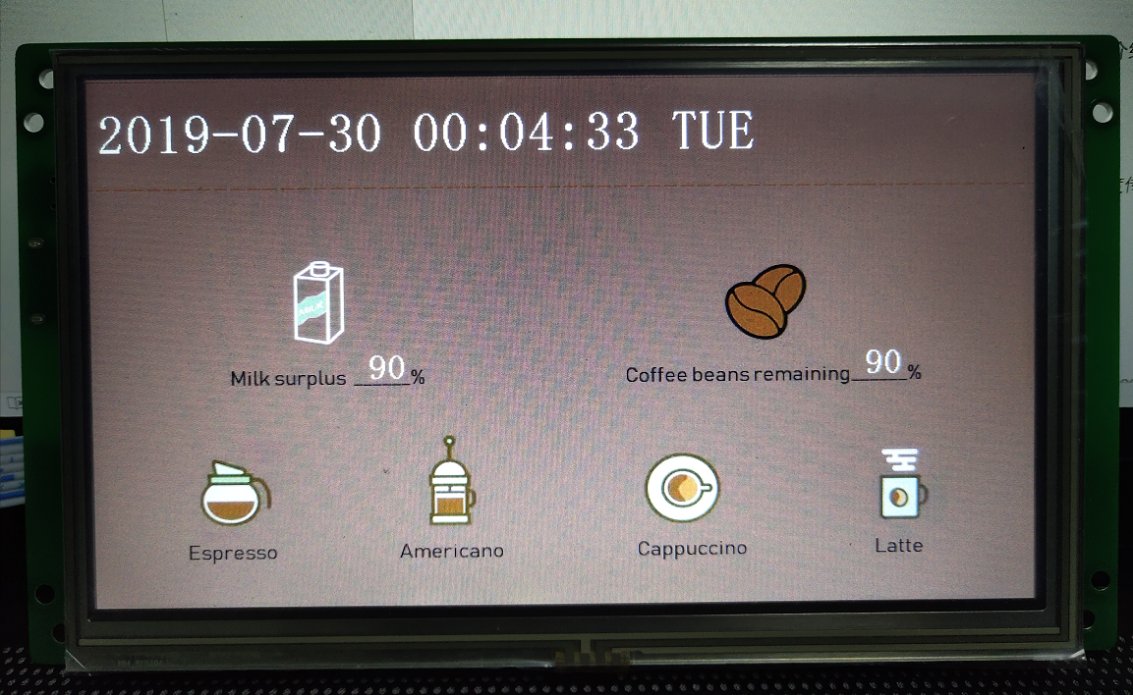

# STM32F103RCT6

**[STM32F103RCT6](https://www.st.com/en/microcontrollers-microprocessors/stm32f103rc.html)** MCU has powerful functions. Here are the basic parameters of the MCU:

* Series: STM32F10X
* Kernel: ARM - COTEX32
* Speed: 72 MHZ
* Communication interface: CAN, I2C, IrDA, LIN, SPI, UART/USART, USB
* Peripheral equipment: DMA, motor control PWM, PDR, POR, PVD, PWM, temperature sensor, WDT
* Program storage capacity: 256KB
* Program memory type: FLASH
* RAM capacity: 48K
* Voltage - power supply (Vcc/Vdd) : 2 V ~ 3.6 V
* Oscillator: internal
* Operating temperature: -40°C ~ 85°C
* Package/housing: 64-lqfp

In this project, I will use UART, GPIO, Watch Dog and Timer of STM32F103RCT6.

The development of these peripherals is documented below.

STM32 USES Keil MDK software development, which is no stranger to you, so I will not introduce the installation method of this software.

STM32 can be simulated online by j-link or st-link and other simulation tools. The following picture is the STM32 circuit board I used:

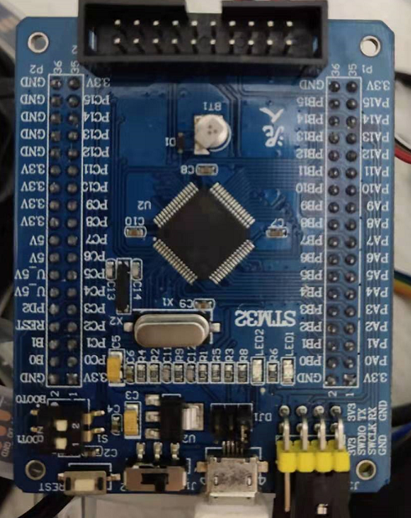

## UART serial

STM32F103RCT6 has several serial ports. In this project, I used the serial port channel PA9/PA10, and the serial port baud rate was set at 115200.

void uart_init(u32 bound){

GPIO_InitTypeDef GPIO_InitStructure;

USART_InitTypeDef USART_InitStructure;

NVIC_InitTypeDef NVIC_InitStructure;

RCC_APB2PeriphClockCmd(RCC_APB2Periph_USART1|RCC_APB2Periph_GPIOA, ENABLE); //Clock

//USART1_TX GPIOA.9

GPIO_InitStructure.GPIO_Pin = GPIO_Pin_9; //PA.9

GPIO_InitStructure.GPIO_Speed = GPIO_Speed_50MHz;

GPIO_InitStructure.GPIO_Mode = GPIO_Mode_AF_PP;

GPIO_Init(GPIOA, &GPIO_InitStructure);//GPIOA.9

//USART1_RX GPIOA.10

GPIO_InitStructure.GPIO_Pin = GPIO_Pin_10;//PA10

GPIO_InitStructure.GPIO_Mode = GPIO_Mode_IN_FLOATING;

GPIO_Init(GPIOA, &GPIO_InitStructure);//GPIOA.10

//Usart1 NVIC

NVIC_InitStructure.NVIC_IRQChannel = USART1_IRQn;

NVIC_InitStructure.NVIC_IRQChannelPreemptionPriority=3 ;

NVIC_InitStructure.NVIC_IRQChannelSubPriority = 3;

NVIC_InitStructure.NVIC_IRQChannelCmd = ENABLE;

NVIC_Init(&NVIC_InitStructure);

//USART

USART_InitStructure.USART_BaudRate = bound;

USART_InitStructure.USART_WordLength = USART_WordLength_8b;

USART_InitStructure.USART_StopBits = USART_StopBits_1;

USART_InitStructure.USART_Parity = USART_Parity_No;

USART_InitStructure.USART_HardwareFlowControl = USART_HardwareFlowControl_None;

USART_InitStructure.USART_Mode = USART_Mode_Rx | USART_Mode_Tx;

USART_Init(USART1, &USART_InitStructure);

USART_ITConfig(USART1, USART_IT_RXNE, ENABLE);

USART_Cmd(USART1, ENABLE);

}

u8 USART_RX_END=0;

void USART1_IRQHandler(void) //Uart1 handler

{

u8 Res;

if(USART_GetITStatus(USART1, USART_IT_RXNE) != RESET)

{

if(USART_RX_END==0)

{

Res =USART_ReceiveData(USART1);

USART_RX_BUF[USART_RX_STA]=Res ;

USART_RX_STA++;

if(USART_RX_STA>8)

{

USART_RX_END=1;

}

}

}

}

## GPIO

In the user interface of this project, there are a total of four buttons, which are actually the making of four kinds of coffee. In the coffee machine, controlling the amount of coffee beans, milk consumption and water flow of different coffees is actually realized by controlling sensors and relays, while I simply control the GPIO pin first.

void PAD_INIT(void)

{

GPIO_InitTypeDef GPIO_InitStructure;

RCC_APB2PeriphClockCmd(RCC_APB2Periph_GPIOB|RCC_APB2Periph_GPIOE, ENABLE); //ENABLE CLOCK

GPIO_InitStructure.GPIO_Pin = GPIO_Pin_0|GPIO_Pin_1|GPIO_Pin_2|GPIO_Pin_3; //-->PB config

GPIO_InitStructure.GPIO_Mode = GPIO_Mode_Out_PP; // PP OUT

GPIO_InitStructure.GPIO_Speed = GPIO_Speed_50MHz; //GPIO SPEED 50MHz

GPIO_Init(GPIOB, &GPIO_InitStructure);

GPIO_SetBits(GPIOB,GPIO_Pin_0|GPIO_Pin_1|GPIO_Pin_2|GPIO_Pin_3); //config out hight

}

void CoffeeSelect(u8 LightSelect,u8 Onflag)

{

u16 gpio_select;

if(LightSelect==Espresso)

gpio_select=GPIO_Pin_0;

else if(LightSelect==Americano)

gpio_select=GPIO_Pin_1;

else if(LightSelect==Cappuccino)

gpio_select=GPIO_Pin_2;

else if(LightSelect==Latte)

gpio_select=GPIO_Pin_3;

if(Onflag==LightOn)

GPIO_SetBits(GPIOB,gpio_select);

else

GPIO_ResetBits(GPIOB,gpio_select);

}

## Timer

When initializing the timer, specify the frequency division coefficient PSC, here is our system clock (72MHz) for frequency division

Then specify the reload value arr, which means that when our timer reaches this arr, the timer will reload other values.

For example, when we set the timer to count up, the value of the timer count is equal to arr and will be cleared by 0 and recalculated

The timer count is reloaded and once is an Update

Calculate the Update time formula Tout = ((arr+1)*(PSC +1))/Tclk

Formula derivation :Tclk is the clock source of timer, here is 72Mhz

We divide the allocated clock frequency, specify the frequency division value as PSC, then divide our Tclk into PSC +1, the final frequency of our timer is Tclk/(PSC +1) MHz

So what we mean by the frequency here is that we have 1s of Tclk over PSC +1 M Numbers (1M=10 ^ 6), and the time for each number is PSC +1 /Tclk, and it's easy to understand that the inverse of the frequency is the period, and the period for each number here is PSC +1 /Tclk seconds and then we go from 0 to arr is (arr+1)*(PSC +1)/Tclk

For example, let's set arr=7199 and PSC =9999

We divided 72MHz into 9999+1 is equal to 7200Hz

This is 9,000 counts per second, and each count is 1/7,200 of a second

So we're recording 9,000 Numbers here to go to the timer update (7199+1)*(1/7200)=1s, so 1s goes to an update.

I needed a timer interrupt to time how much coffee and milk I had left, so I wrote the code for the timer driver and wrote a timer interrupt function：

void TIM3_Int_Init(u16 arr,u16 psc)

{

TIM_TimeBaseInitTypeDef TIM_TimeBaseStructure;

NVIC_InitTypeDef NVIC_InitStructure;

RCC_APB1PeriphClockCmd(RCC_APB1Periph_TIM3, ENABLE); //clock

TIM_TimeBaseStructure.TIM_Period = arr;

TIM_TimeBaseStructure.TIM_Prescaler =psc;

TIM_TimeBaseStructure.TIM_ClockDivision = 0; //TDTS = Tck_tim

TIM_TimeBaseStructure.TIM_CounterMode = TIM_CounterMode_Up;

TIM_TimeBaseInit(TIM3, &TIM_TimeBaseStructure);

TIM_ITConfig(TIM3,TIM_IT_Update,ENABLE );

NVIC_InitStructure.NVIC_IRQChannel = TIM3_IRQn;

NVIC_InitStructure.NVIC_IRQChannelPreemptionPriority = 0;

NVIC_InitStructure.NVIC_IRQChannelSubPriority = 3;

NVIC_InitStructure.NVIC_IRQChannelCmd = ENABLE;

NVIC_Init(&NVIC_InitStructure);

TIM_Cmd(TIM3, ENABLE); //enable

}

//handler

void TIM3_IRQHandler(void) //TIM3

{

if (TIM_GetITStatus(TIM3, TIM_IT_Update) != RESET)

{

TIM_ClearITPendingBit(TIM3, TIM_IT_Update );

//Add your code here

}

}

## Watch Dog

To prevent the system from crashing while the program was running, I added the watchdog.In fact, all projects that use the MCU generally use a watchdog.

STM32 has two built-in watchdogs, providing greater security, time accuracy and flexibility.Two watchdog devices (independent watchdog and window watchdog) can be used to detect and resolve faults caused by software errors.When the counter reaches a given timeout value, an interrupt (window watchdog only) or system reset is triggered.

Independent watchdog (IWDG) :

Driven by a dedicated low speed clock (LSI), it works even if the master clock fails.

It is suitable for use in situations where the watchdog is required to work completely independently outside the main program and requires low time accuracy.Window watchdog (WWDG) :

Driven by clock from APB1 clock after frequency division.Detect abnormally late or premature application operation through a configurable time window.Suitable for programs that require watchdogs to function in precise timing Windows.

I use IWDG.

int main(void)

{

delay_init(); //delay init

NVIC_PriorityGroupConfig(NVIC_PriorityGroup_2); //NVIC INIT

uart_init(115200); //UART INIT

PAD_INIT(); //Light Init

IWDG_Init(4,625);

while(1)

{

if(USART_RX_END)

{

switch (USART_RX_BUF[5])

{

case Espresso:

CoffeeSelect(Espresso,USART_RX_BUF[8]);

break;

case Americano:

CoffeeSelect(Americano,USART_RX_BUF[8]);

break;

case Cappuccino:

CoffeeSelect(Cappuccino,USART_RX_BUF[8]);

break;

case Latte:

CoffeeSelect(Latte,USART_RX_BUF[8]);

break;

default:

USART_RX_END=0;

USART_RX_STA=0;

break;

}

USART_RX_STA=0;

USART_RX_END=0;

}

delay_ms(10);

IWDG_Feed();

}

}

The Main logic in the Main function is as follows:

Finally, add the code in the timer interrupt:

In the timer interrupt, my goal is to check how much coffee and milk is left, and then send the detected value to the display screen through a serial port.

u8 timer_cnt=0;

void TIM3_IRQHandler(void) //TIM3

{

if (TIM_GetITStatus(TIM3, TIM_IT_Update) != RESET)

{

TIM_ClearITPendingBit(TIM3, TIM_IT_Update );

timer_cnt++;

if(timer_cnt>=200)

{

milk_send[6]=milk();

UART1_Send_Array(milk_send,7);

beans_send[6]=beans();

UART1_Send_Array(beans_send,7);

}

}

}

Measuring how much milk and coffee beans are left over is usually done by sensors. Simple methods include pressure sensors, which measure the current weight of the milk and coffee beans to determine how much is left over.

**Write in the last**

This article only records the simple development process of my project. Considering the confidentiality of the company's project, the UI display interface I used was also made by myself, not the real UI display interface of this project.

The code part of STM32 only adds the peripheral driver of MCU and related logic code. Also considering the confidentiality of the company's project, the specific key technology part is not given, please understand. However, according to the code I provided,  cooperate with STONE display screen. my friends who are also software engineers need only spend a few days to add key technical parts to my code framework to complete the project.